a)

root@DESKTOP-38F20DM:/.../CSS342/Program4# ./a.out 32

|  |  |
| --- | --- |
| initial:  items[0] = 7  items[1] = 6  items[2] = 9  items[3] = 19  items[4] = 17  items[5] = 31  items[6] = 10  items[7] = 12  items[8] = 13  items[9] = 26  items[10] = 11  items[11] = 18  items[12] = 27  items[13] = 3  items[14] = 28  items[15] = 2  items[16] = 20  items[17] = 24  items[18] = 8  items[19] = 22  items[20] = 14  items[21] = 23  items[22] = 5  items[23] = 29  items[24] = 30  items[25] = 1  items[26] = 16  items[27] = 15  items[28] = 21  items[29] = 25  items[30] = 0  items[31] = 4 | sorted:  items[0] = 0  items[1] = 1  items[2] = 2  items[3] = 3  items[4] = 4  items[5] = 5  items[6] = 6  items[7] = 7  items[8] = 8  items[9] = 9  items[10] = 10  items[11] = 11  items[12] = 12  items[13] = 13  items[14] = 14  items[15] = 15  items[16] = 16  items[17] = 17  items[18] = 18  items[19] = 19  items[20] = 20  items[21] = 21  items[22] = 22  items[23] = 23  items[24] = 24  items[25] = 25  items[26] = 26  items[27] = 27  items[28] = 28  items[29] = 29  items[30] = 30  items[31] = 31 |

elapsed time for semi-in-place mergesort: 23

b)

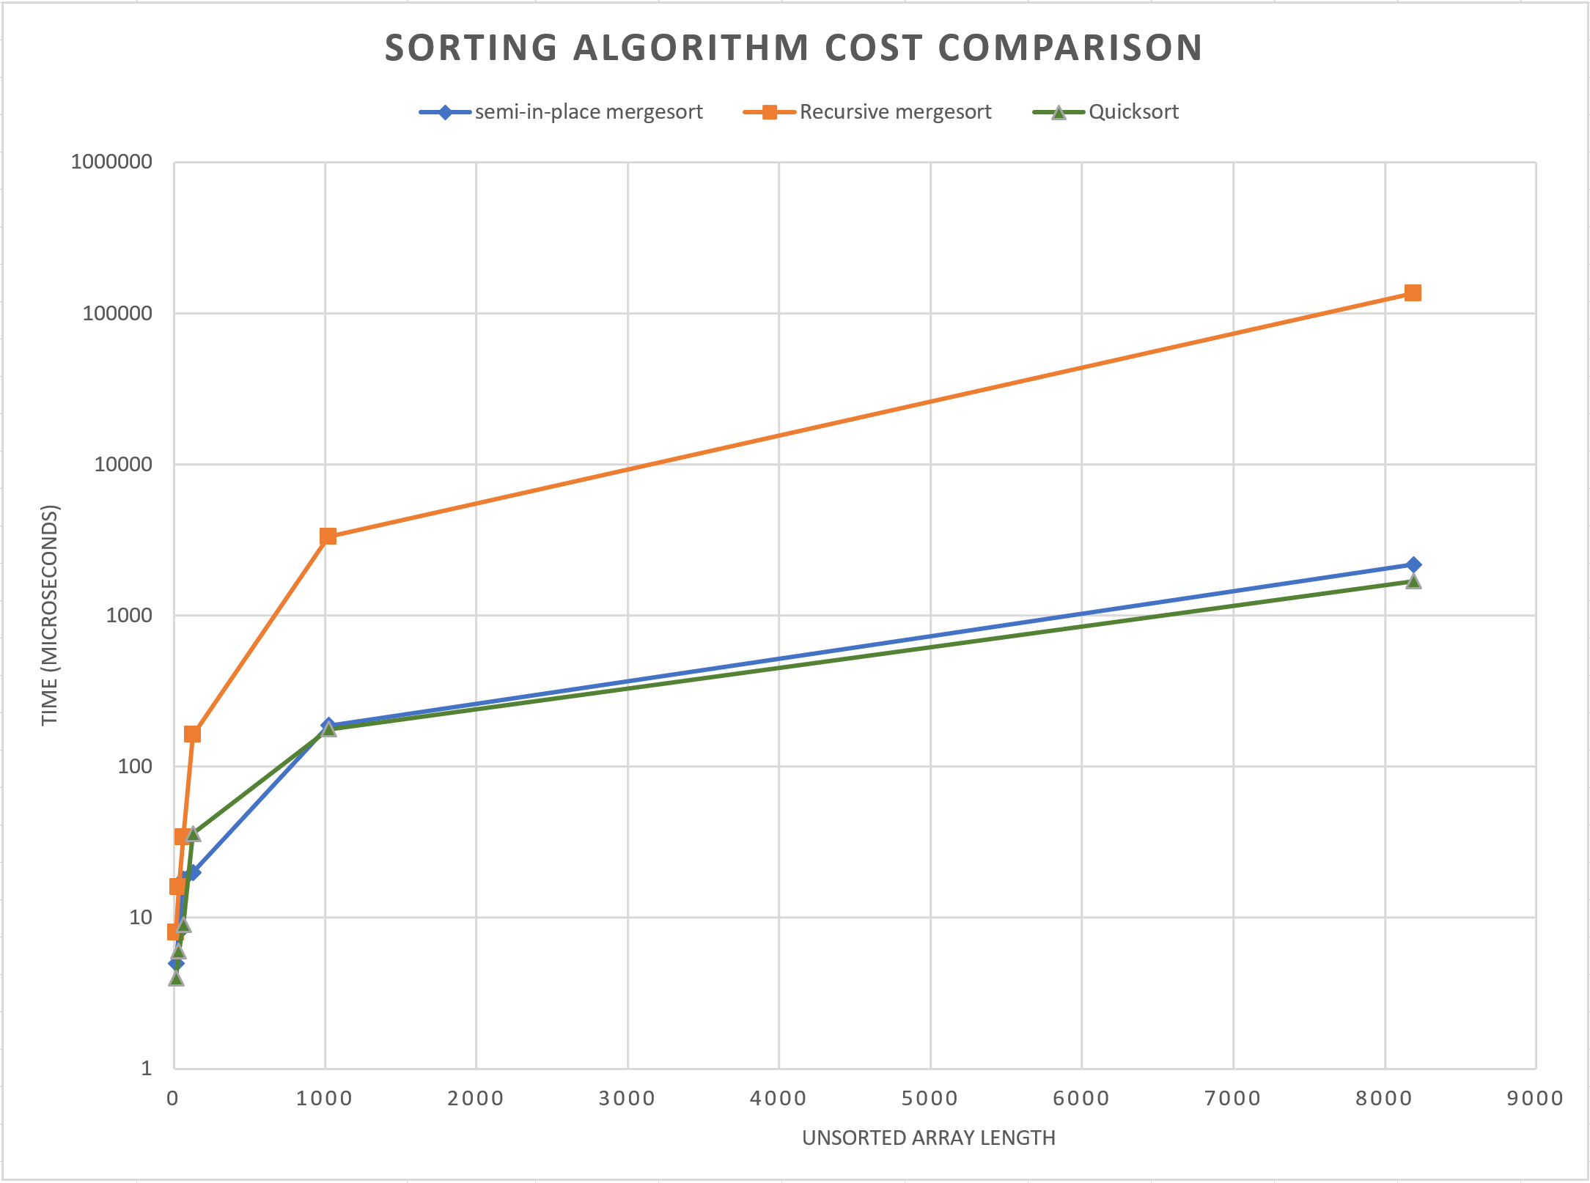

The y-axis is logarithmic to show the lower values better. Non-log scaled version here shows that large difference in cost that the original merge sort has vs the other two.

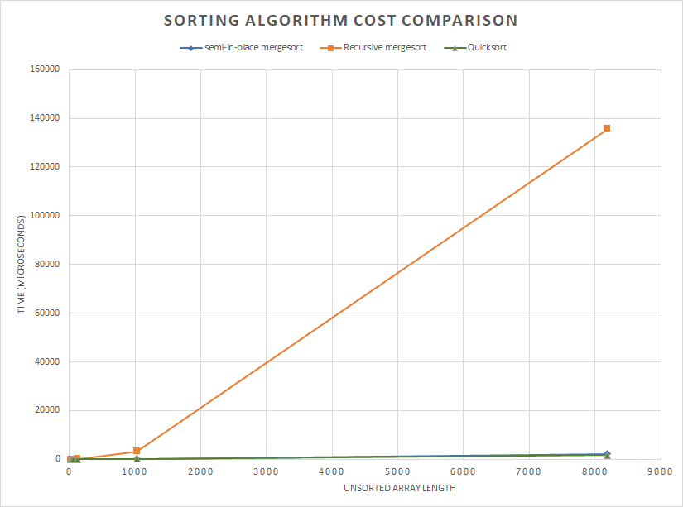

root@DESKTOP-38F20DM:/.../CSS342/Program4# ./a.out 16

elapsed time for semi-in-place mergesort: 5

elapsed time for Recursive mergesort: 8

elapsed time for Quicksort: 4

root@DESKTOP-38F20DM:/.../CSS342/Program4# ./a.out 32

elapsed time for semi-in-place mergesort: 8

elapsed time for Recursive mergesort: 16

elapsed time for Quicksort: 6

root@DESKTOP-38F20DM:/.../CSS342/Program4# ./a.out 64

elapsed time for semi-in-place mergesort: 18

elapsed time for Recursive mergesort: 34

elapsed time for Quicksort: 9

root@DESKTOP-38F20DM:/.../CSS342/Program4# ./a.out 128

elapsed time for semi-in-place mergesort: 20

elapsed time for Recursive mergesort: 162

elapsed time for Quicksort: 36

root@DESKTOP-38F20DM:/.../CSS342/Program4# ./a.out 1024

elapsed time for semi-in-place mergesort: 187

elapsed time for Recursive mergesort: 3327

elapsed time for Quicksort: 177

root@DESKTOP-38F20DM:/.../CSS342/Program4# ./a.out 8192

elapsed time for semi-in-place mergesort: 2174

elapsed time for Recursive mergesort: 135645

elapsed time for Quicksort: 1691